G6

User Manual

Content
Content 2
G6 Specification 3
1 Home page 4
1.1 Upper status 5
1.2 Middle Widgets 5
1.3 Moving and unloading of widgets 5
1.4 Middle Function Icon 6
1.5 Lower multimedia and Air-conditioning bar 7
1.5.1 Lower multimedia bar 7
1.5.2 Lower Air-conditioning bar 8
2 Instruction of Icon Function 10
2.1 Bluetooth telephone 10
2.2 Bluetooth music 12
2.3 Music 14
2.4 HD-Video Player 15
2.5 Radio 16
2.6 DSP 17
8 Toppal Voice 19

G6 Specification
Operating System | O.S | Android 11
Processor | CPU | Qualcomm Snapdragon 665 Octa-core
 | Chipset | QCM6125
Memory | RAM | 4G/8GB
 | ROM | 64G/128GB
Display | Touch Screen | G+G Capacitive touch screen
 | Display Screen | Anti-glare IPS full view screen
 | Resolution | 10.4/12.1inch: 1024*768  11.8/13.6/16inch:1920*1080  13inch:1600*1200
Navigation | Satellite Search Positioning | GPS/Beidou/GLONASS
 | Navigation Maps | Google Map/IGO/Sygic/Waze/Yandex etc
Application | Bluetooth | Bluetooth 5.0 hands free call /music play
 | Radio Module | SI4745 module, support RDS function
 | Phone Link | Support Carplay/ Android auto/ HiCar
 | Voice Control | More than 10 Languages smart voice control, includes wake-up free command
Multimedia | Sound Effect | Built-in DSP (16 bands of EQ),multiple sound effect adjustment
 | Audio Output | Built-in TDA7850 Amplifier, Audio output power 45W*4
 | Audio Format | MP3,WMA,APE,FLAC,AAC etc
 | Video Format | MP4,AVI,MOV,RMVB,FLV,MKV,3GP,MPG etc  support 4K@30fps video play
 | Image Format | JPG,JPEG,BMP,GIF,etc
Network | Connecting | 4G /WiFi / mobile phone hotspot
 | 4G Network Frequency | LTE-FDD:B1/3/5/7/8/20/28
 |  | LTE-FDD:B38/40/41
 |  | WCDMA:B1/2/5/8
 |  | GSM:850/900/1800/1900MHz
 | WIFI connecting | WIFI 2.4G+5G 802.11a/b/g/n/ac
Expansion | Input Signal | Support 1080p cameras, AHD+CVBS signal
 | Video Output | USB to CVBS (Optional)
 | Reverse | Reversing and radar display
 | USB | 2 ways USB 2.0
Standby mode | Boot | Support quick start (reboot)

1 Home page
The home page mainly has two different styles, which can be changed in the system settings.
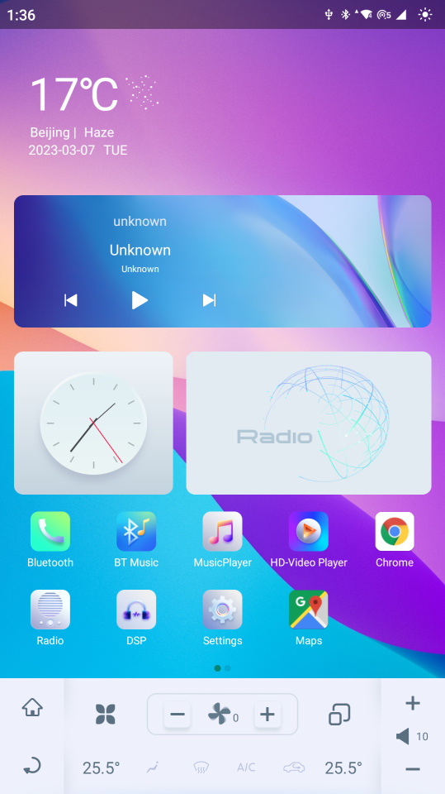
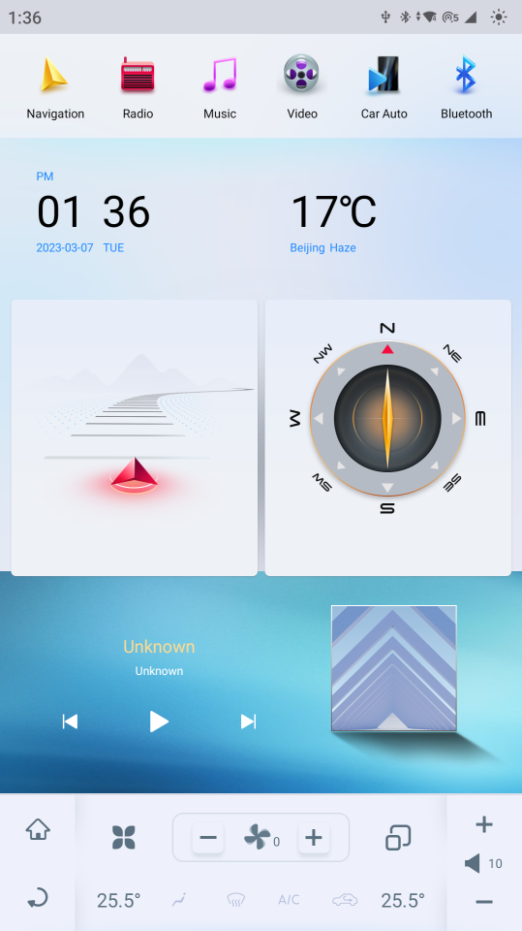
Modern style at the daytime
Classic style at the daytime

Page Layout
Upper | Status bar
Middle | Widget
 | Function Icon
Lower | Multimedia bar
 | Air Conditioning Bar

1.1 Upper status: Composed of a semi-transparent underlay, fixed and suspended above the whole page. It includes time ,WIFI , Bluetooth , hotspot , and 4G connection status . At the same time, click the small sun icon to make a simple adjustment of screen brightness.

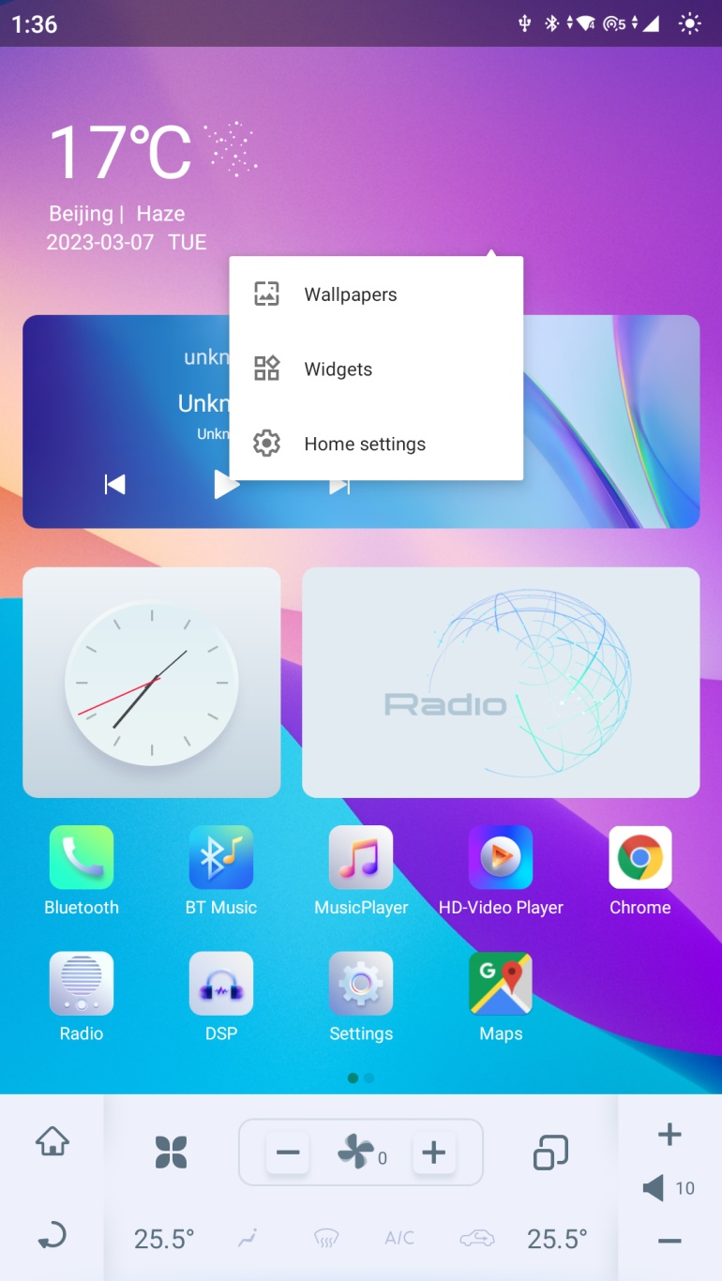
1.2 Middle Widgets: Press on the blank screen for a longer-than-usual time, and the widgets icon appears. Click to enter the widget page, select the widget options available for each application, and display them on the main screen.
1.3 Moving and unloading of widgets: Keep pressing the widget for 2 seconds to enter the drag mode, drag the widget to the position you want, and then release the icon. If you want to unload the widget, try to press and hold the widget icon and drag it to the removal area where the page appears. Release the icon to unload the widget.

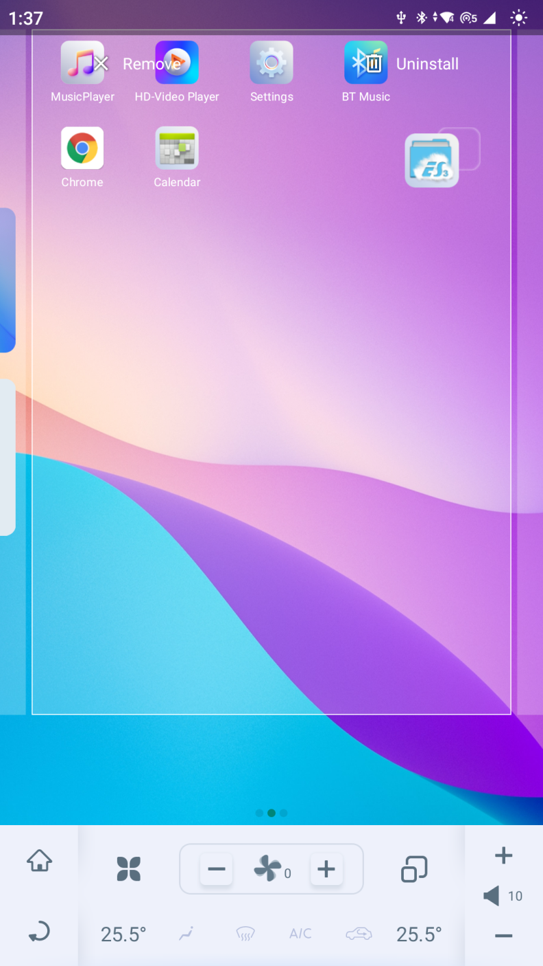
1.4 Middle Function Icon
There are 10 built-in icons in the system, and you can add third-party application icons according to your preferences. Click to enter the application. Press and hold the icon for 3 seconds to delete, move and uninstall the icon. When you move the icon to the remove text at the top left of the page, you can remove the icon from the page; When you move the icon to the uninstall text that appears at the top right of the page, you can uninstall the application. When you move the icon to the left and right border of the page, it will automatically slide to the next page and add a new page.

1.5 Lower multimedia and Air-conditioning bar:
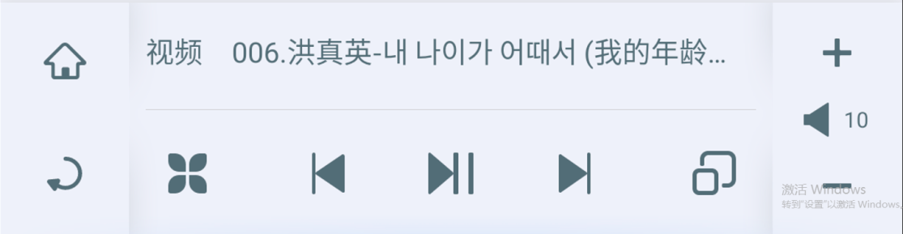

1.5.1 Lower multimedia bar:
- Click the icon to back to the home page.
- Click the icon to exit the current application.
- Click the icon to pop-up the application page.
- Click the icon to play the previous music or video.
- Click the icon to pause or play the current video and music.
- Click the icon to play the next music or video.
- Click the icon to view the background applications; Long press to enter split screen.
- Click the icon to increase the volume, click the icon to decrease the volume; This icon display the volume number, and click this icon to select mute or open the voice.
- This icon shows the currently playing video or audio multimedia.

1.5.2 Lower Air-conditioning bar:
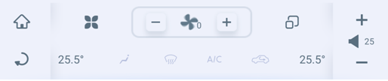

- Click the icon to back to the home page
- Click the icon to exit the current application.
- Click the icon to pop-up the application page.
- Click the icon to view the background applications; Long press to enter split screen.
- Click the icon to increase the volume, click the icon to decrease the volume; This icon display the volume number, and click this icon to select mute or open the voice.
- Click the icon to open the air-conditioner, pop-up the whole air-conditioning page and change the mode to lower air flow; click it for the second time to change the mode to lower and middle air flow; click it for the third time to close the air-conditioner.
- Click the icon to open the front windshield defrost and pop-up the whole air-conditioning page.
- Click the icon to open the air-conditioner compressor and pop-up the whole air-conditioning page.
- Click the icon to open the recirculation and pop-up the whole air-conditioning page.
- Click the icon to decrease the wind speed, click the icon to increase the wind speed; this icon display the current wind speed.
- for upper air flow
- for middle air flow
- for lower air flow
- for max the air-conditioner compressor
- for front windshield defrost
- for rear window defrost
- for opening the air-conditioner compressor
- for opening the recirculation
- for seat heating
- for seat ventilation
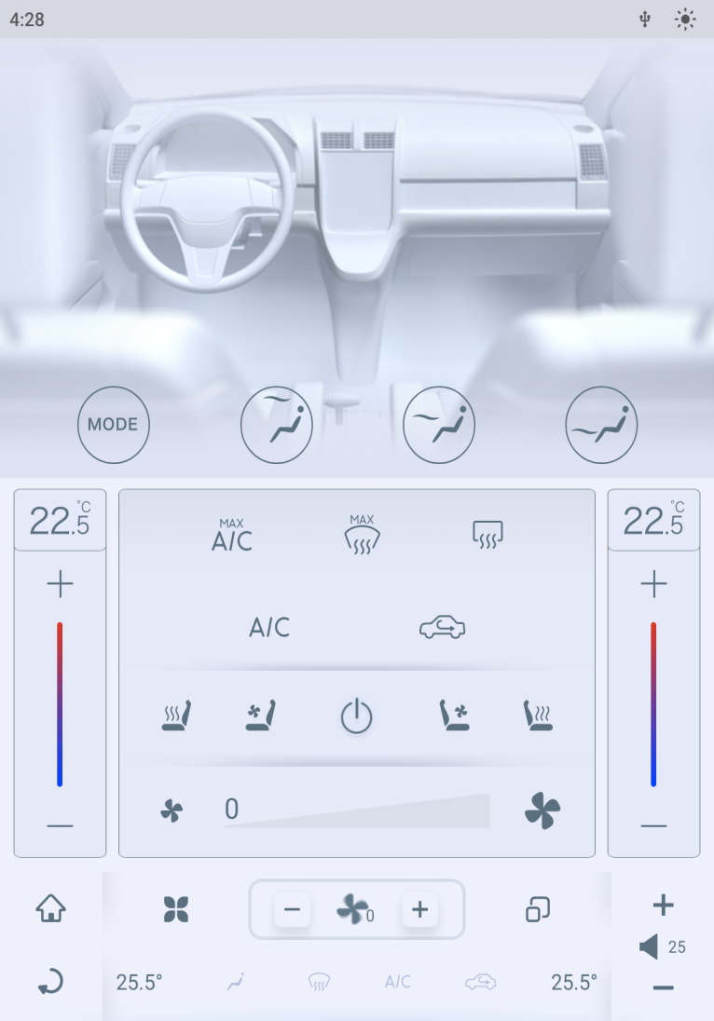
Whole Air-Conditioning Page

- for opening or shutting the air conditioner
- for wind speed regulation and display
- for temperature regulation and display

2 Instruction of Icon Function

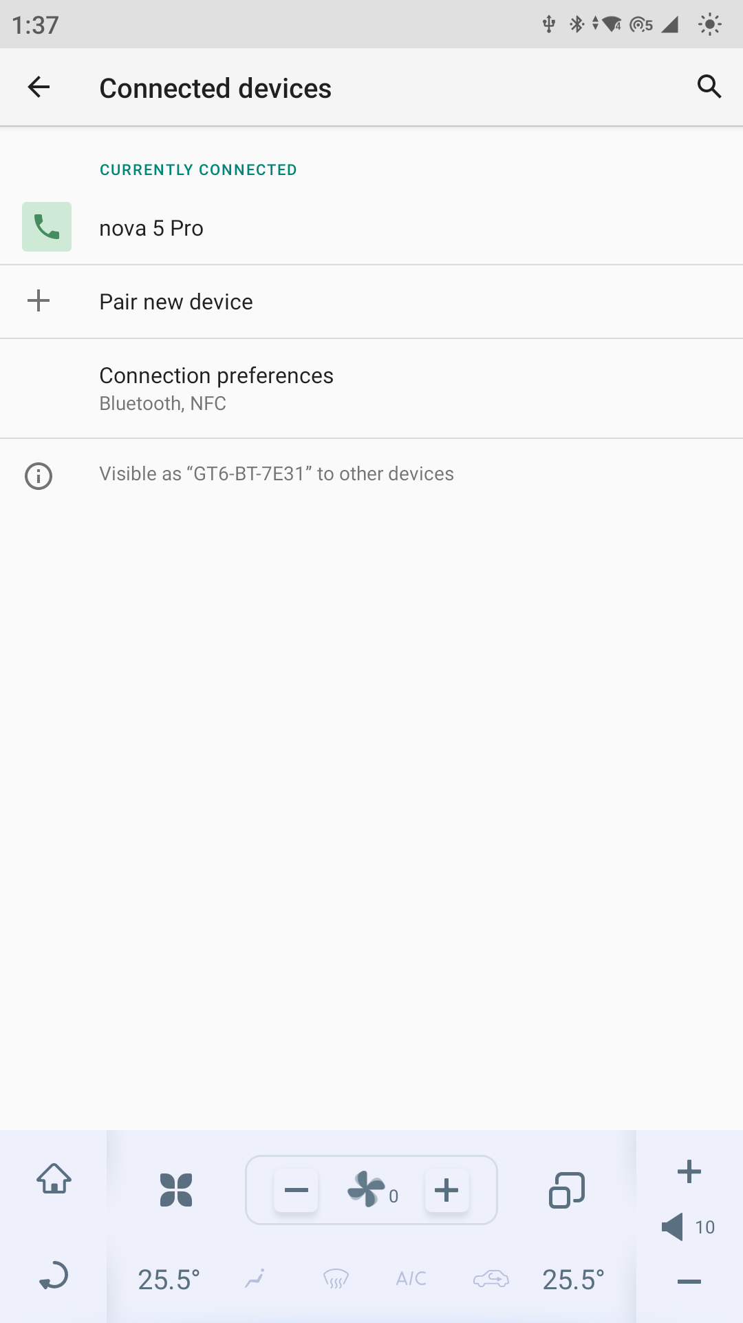
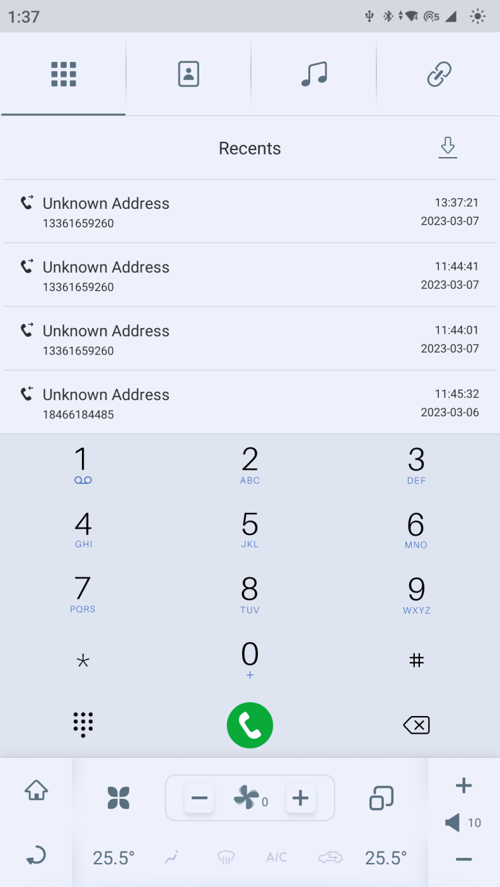
2.1 Bluetooth telephone
- Click the home page icon to enter the Bluetooth telephone
- Bluetooth device connection: Click the icon to connect our device you’re your mobile phone. After the Bluetooth device completes the connection, it can make a call or answer a call after agreeing and completing the data synchronization. Incoming calls will be displayed at the top of the screen in the form of pop-up window
be displayed at the top of the screen in the form of pop-up window.
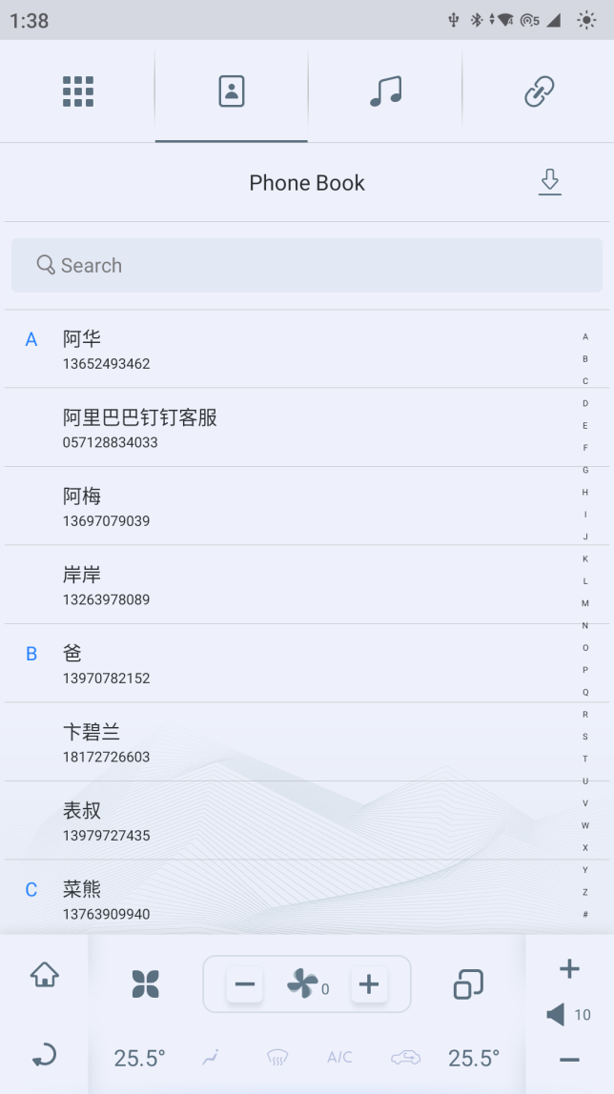
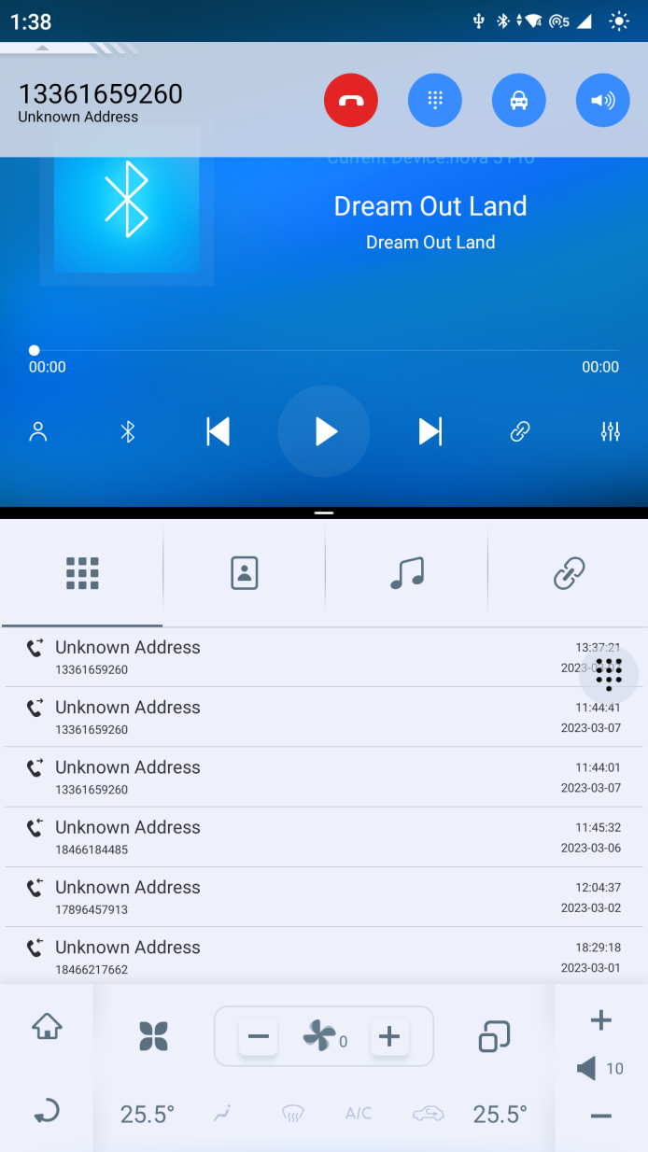
5. Phone Book: Click "Bluetooth phone >＞＞Phone Book " to open the phone book contacts page; Click the download button on the right side of the phone book to synchronize the phone book with your phone. Slide up and down to view the phonebook contacts list; Click any phonebook contact to make a call.
6. Dial: Click "Bluetooth Phone＞＞Dial" to open the dial page; Enter number retrieval: click the number dial and enter the phone number. When entering the number, the corresponding number in the contact list will be displayed on the right side of the page.
3. Recents: The latest call record of the Bluetooth phone. When Bluetooth is connected, the latest call data of the mobile device can be synchronized to the call list of the vehicle. Click "Recent Calls" to open the list of recent calls; Slide the list up and down to browse the recent call records; Click any call record to make a call.
4. Split view: Bluetooth telephone supports split view function, as shown on the left. You can operate two applications on the premise of split screen.

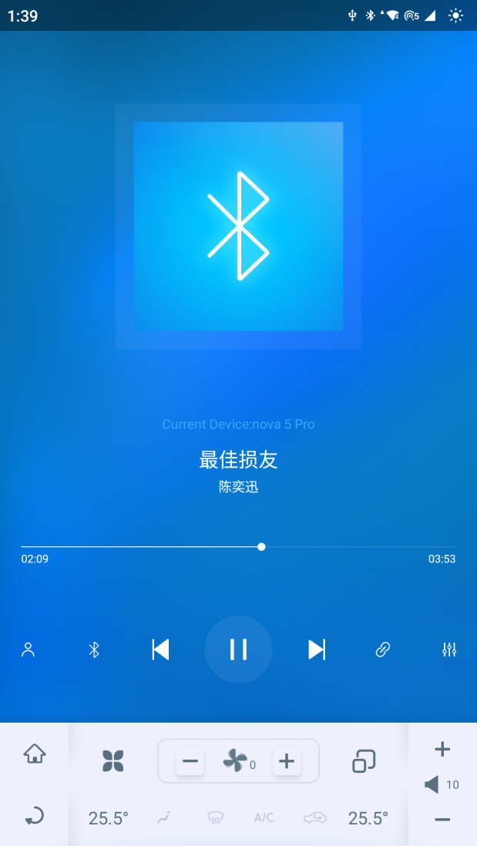
2.2 Bluetooth music

- Click the home page icon “BT Music” 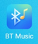 to open the Bluetooth music playing page
- Bluetooth device connection: Click the icon to open the Bluetooth device page and display the name of the connected Bluetooth device.
- Switch Bluetooth device: Click the icon to enter the Bluetooth connection page and search for a new Bluetooth device to connect.
- Play: Click the icon to switch the previous or next song. Click the icon to pause or play the current music. But please be informed that you cannot adjust the progress of mobile music by dragging the progress bar on our device in Bluetooth music page.

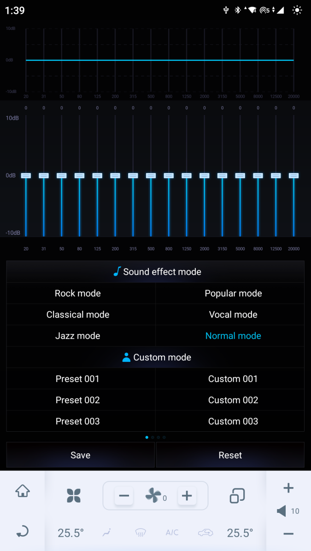

- DSP: Click the icon to enter the DSP page. You can adjust the sound size, intensity, high and low pass filtering, etc. in this application. The detailed introduction of this application is in the following text, which can be queried and read as your preference.
- Split view: Bluetooth telephone supports split view function, as shown in the figure above. You can operate two applications on the premise of split screen. Go and see the following documents for the detailed description of this function, and there will be no further description here and later for other applications.

2.3 Music
- Click the home page icon to enter the music play page.
- The functions of the relevant keys have been described in the previous section "Bluetooth Music", and will not be repeated here.
- Click the icon to switch the playback interface to classic CD.
- Select playback modes: There are single cycle, shuffle, folder cycle and playlist cycle four playback modes for you to choose.
Single cycle: In this mode, the same song will be played repeatedly. If you do not actively switch to the next song or pause, the music will keep playing repeatedly. However, please note that you cannot change songs without switching modes by yourself under the single cycle mode.
Shuffle: In this mode, after the music being played, the system will automatically and randomly select a piece of music to play.
Folder cycle: In this mode, the device will automatically play all songs in the folder one by one in order. However, please be informed that you cannot change songs in other folders without switching modes by yourself under the folder cycle mode.
Playlist cycle: In this mode, the device will automatically play all songs in the playlist one by one in order.
5. Playlist: Click the button to open the playlist and select the local music you want to play.

2.4 HD-Video Player
1. Click the home page icon to enter the HD-video player page.
2. The functions of the relevant icons have been introduced in the previous section and because of the similarity in their function, will not be repeated here.
3. Click the icon to enter the full screen viewing mode.
4. Select Resolution: Click the icon to select the resolution you like. There are four resolution modes for you to choose: 16:9, 4:3, 1:1, and tiling.
5. Picture-in-Picture Mode: Click the icon to return to the home page and form a picture-in-picture mode when playing the movie. You can watch the movie or video in a small window on the home page.

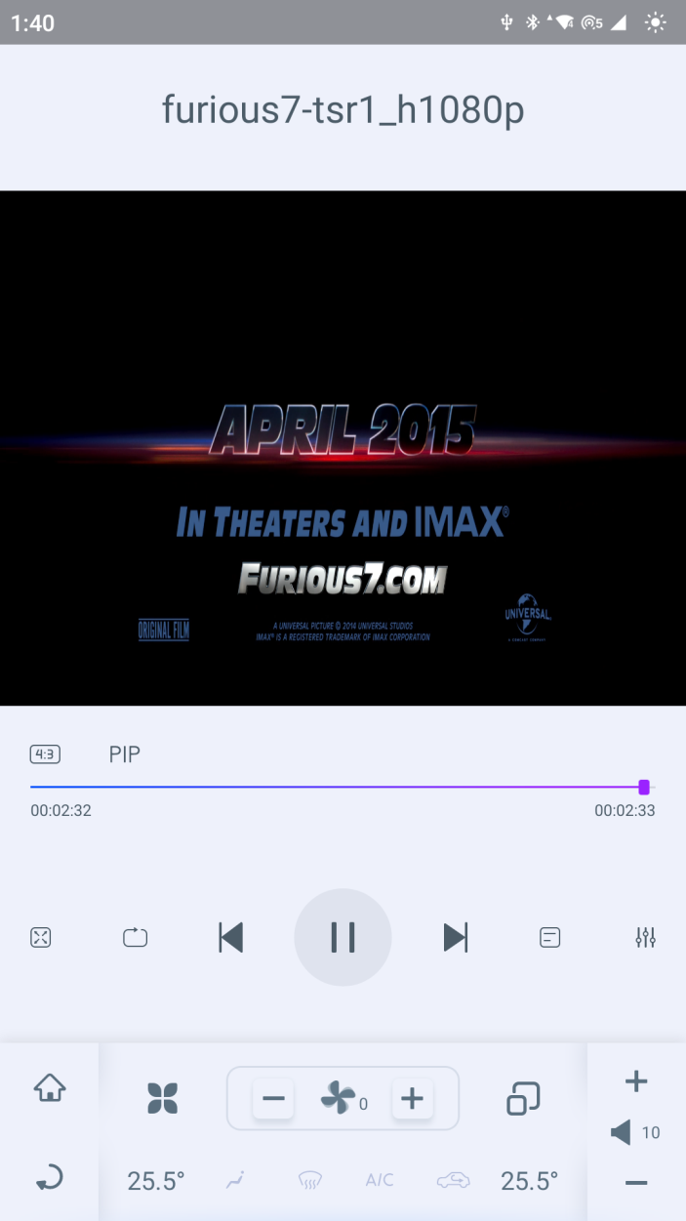

2.5 Radio
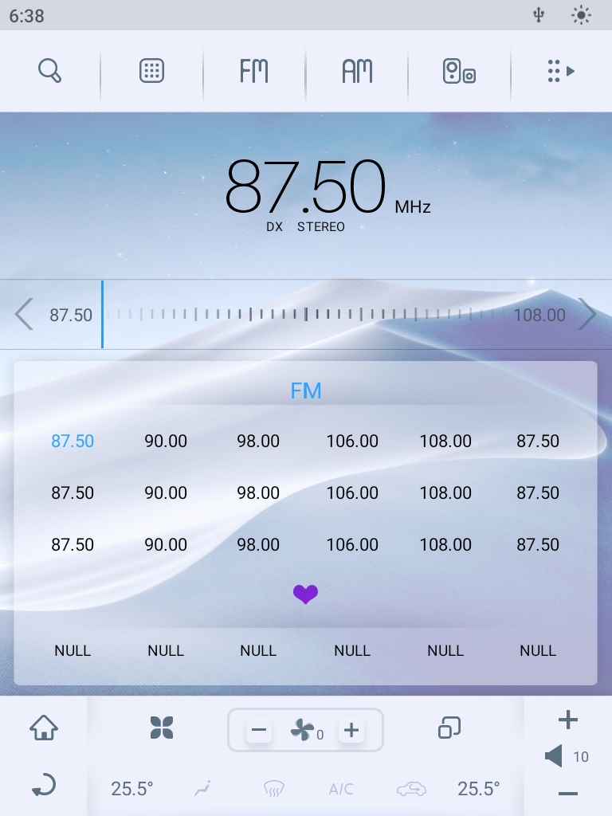
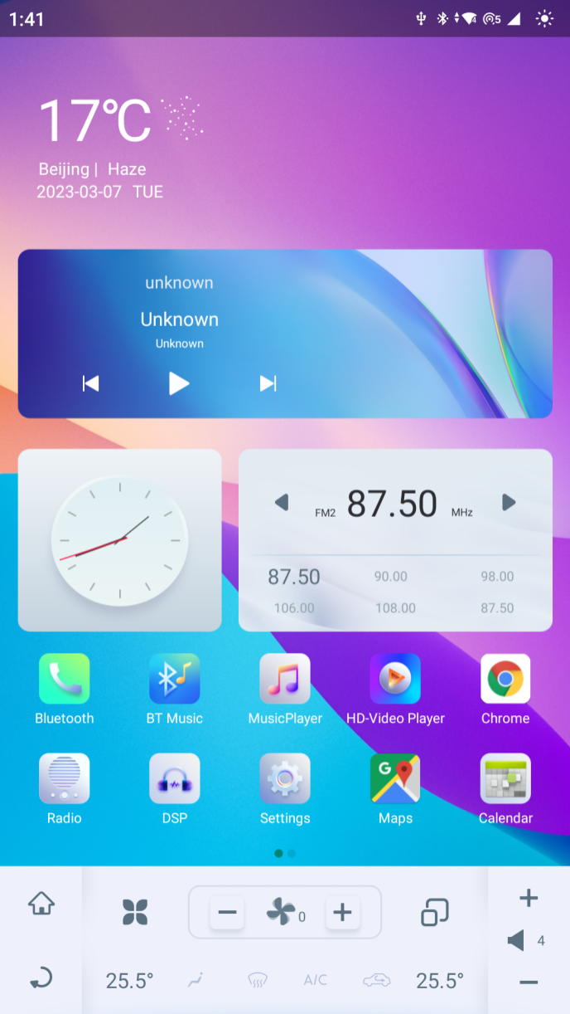
1. Click the icon on the home page to open the radio and begin your radio listening.
2. This radio application can support "FM" and "AM" radio bands. You can adjust and listen to your favorite radio programs according to your needs.
3. Press and hold this icon to automatically search for and adjust the radio.
4. Favorites: Select the channel you want to collect, and the color of the channel you selected will turn into blue. Then press and hold the “NULL” here, and the channel you previously selected will replace ”null” here and be saved.

2.6 DSP
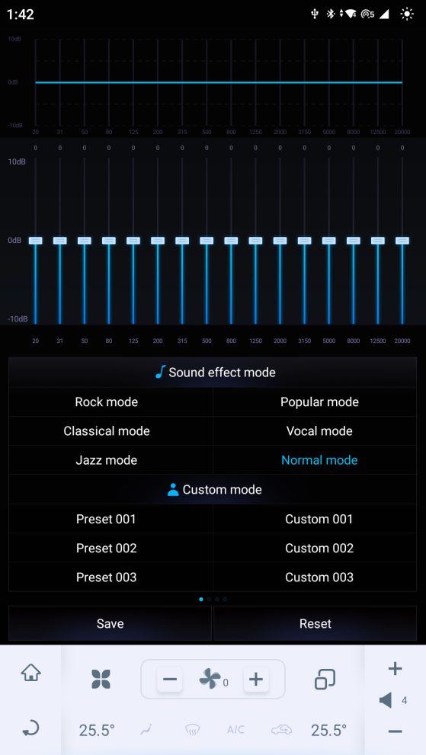
1. Click the icon 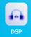 on the home page to enter the DSP page.
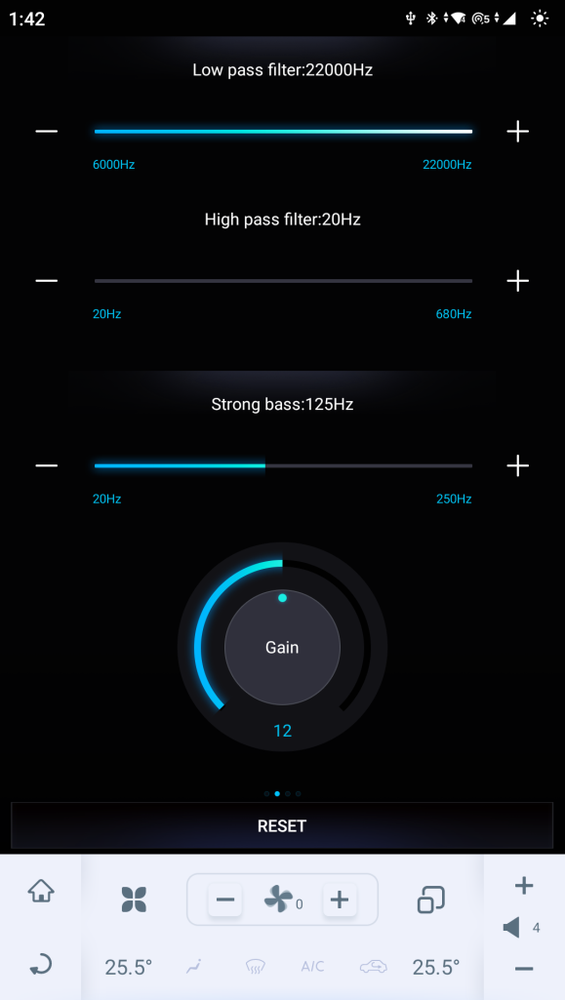
2. Equalizer: The equalizer interface is shown in the left figure. You can adjust the treble, midrange and bass parts of the equalizer by clicking and dragging the slider up and down to adjust to the appropriate number. The highest and lowest values are+10 and - 10. This equalizer has a total of 16 EQ adjustment sliders. At the bottom of the page, three sound effect modes and three customized shortcut options are set. You can click to select and use the customized shortcut saved by the equalizer to achieve the appropriate equalizer sound effect.
3. HPF＆LPF: Swipe the DSP page to the right, and the high and low pass filtering interface will appear. You can adjust the lower and upper limits of the high and low pass filtering by sliding the progress bar.
4. Strong bass: When the strong bass is selected, you can adjust the range of the strong bass by sliding the progress bar.

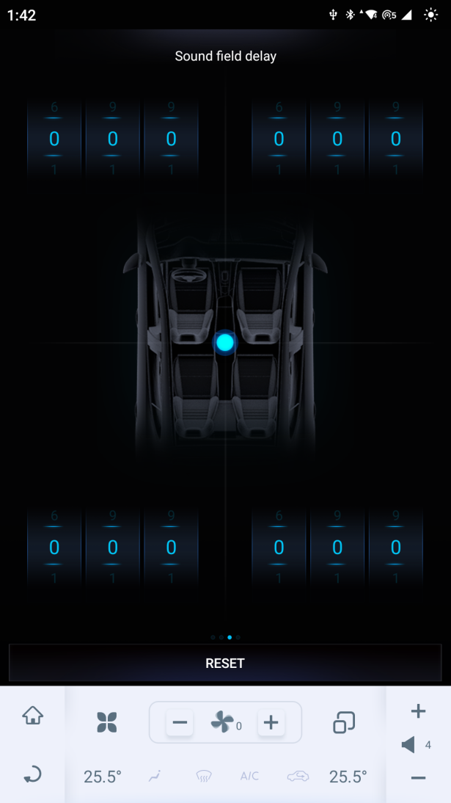

5. Sound field delay: You can adjust the parameters of the four speakers in the car to control the delay time of sound playback to ensure that the sound from different speakers can be heard at the same time., so as to obtain the best listening experience.
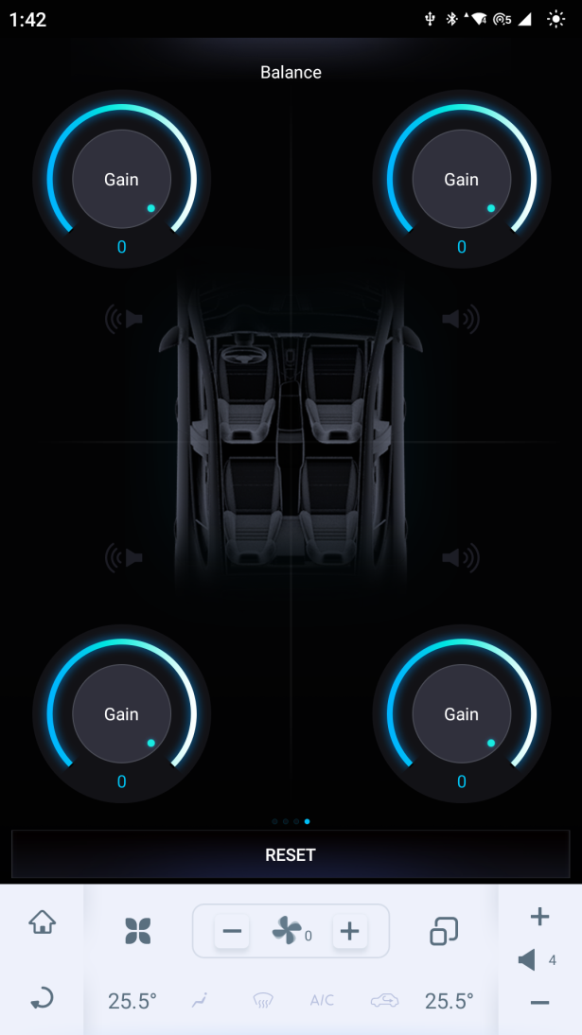
6. Balance: Adjust the gain by sliding the gain wheel. The center point of the sound field can be changed by changing the intensity values of the four positions, and the position of the equilibrium point of the sound field in the vehicle can be controlled at the same time. Change the sound size and intensity of the four stereo systems in the car.

8 Toppal Voice
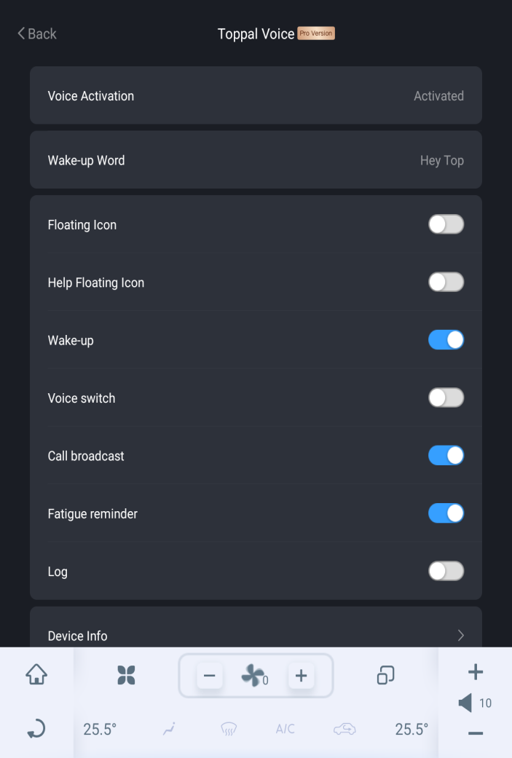

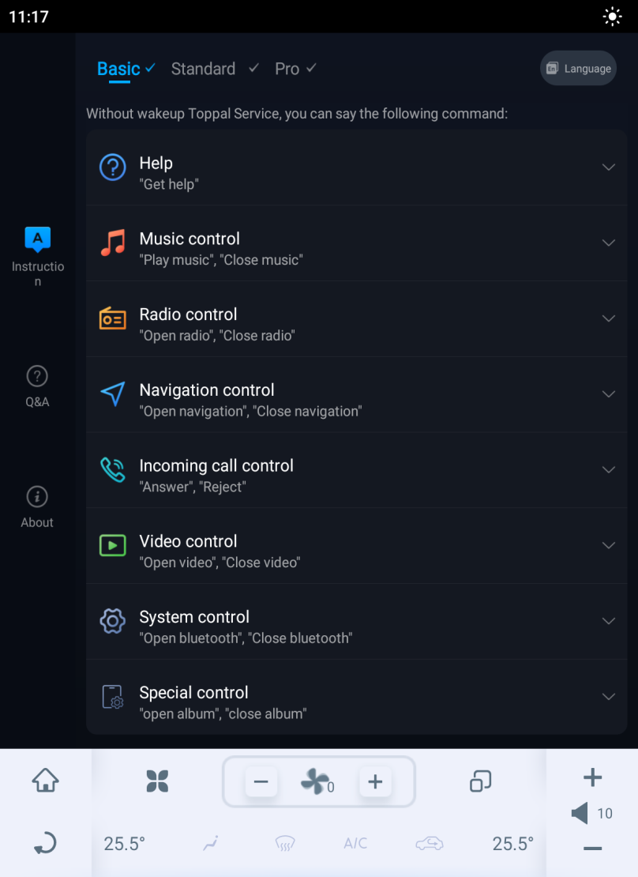
This device supports voice control, Click the icon in all the applications interface to open the Toppal Service. You need to speak the wake-up words “hey, top” before speaking voice commands. And you can also make some basic settings for Toppal Voice in this application.
Click the icon in all the applications interface to open the Toppal Voice. On this page, you can view all voice commands and obtain some product information of Toppal Voice.
